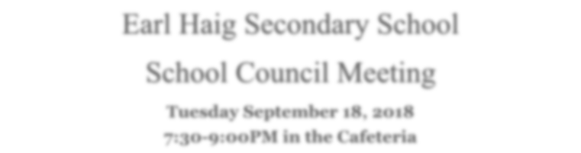

Tuesday, May 7, 2019
7:30-9:00pm in the Cafeteria

The Earl Haig School Council Presents:
Supporting Academic Success: Exam Preparation Techniques & Tips
Agenda
- Co-Chairs Update, Welcome and Introductions – Susan & Chandra
- Student Activity Council Update - Michael Samoilov & Ivy Deng
- Principal’s Update – Renata Gonsalves
- Student Nutrition Program – Stewart Burns, VP

Exam Preparation Techniques & Tips:
Student Tips:
Raewyn Tsai, Assistant Director, LC
Michael Samoilov, President, SAC
Ivy Deng, Vice President, SAC
Staff Tips:
Christine Zaghikian, CL, Guidance
Jeanne Chew, ACL, Science
Christina Chang, ACL, Mathematics & Numeracy
Stewart Burns, VP
Next Meeting Date: September 17, 2019
Annual General Meeting

A l l P a r e n t s a n d G u a r d i a n s a r e W a r m l y I n v i t e d t o A t t e n d !

